

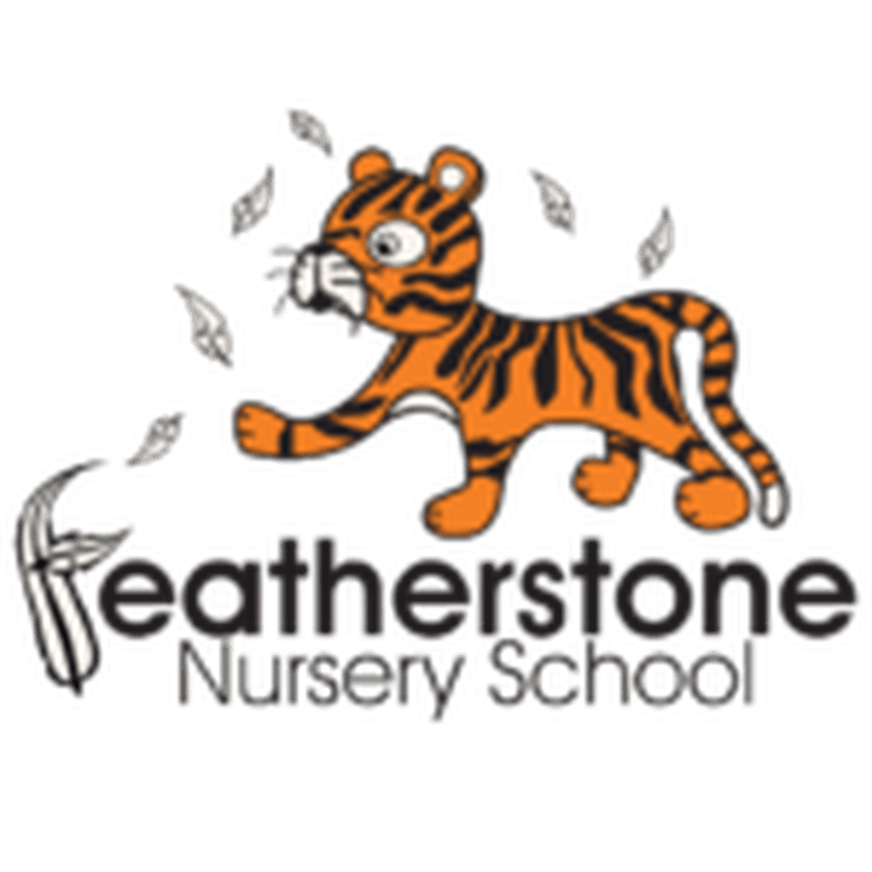

Autumn 2 - Winter and Festivals
Federation of Osborne and Featherstone Nursery Schools Curriculum Guide for Parents and Carers
2 Year Olds | 3 Year Olds | 4 Year Olds
Key Activities:  Exploring celebrations! Learning how to celebrate special occasions. Learning to respond to different types of music and singing familiar songs. Listening to different sounds in the environment. Children will explore different textures and learn new words.  Investigating winter—looking at colours, temperature and changes. | Key Activities:  Understand that we all celebrate different events. What do we do? How do we celebrate? We will learn about bonfire night and explore different textures and colours. We will listen to different sounds and look at pattern and colours. Look for clues about the changes in the season. Sort objects into groups. Solve problems. | Key Activities:  Learn about different celebrations at different times of the year. Learn celebrations have many similarities. Appreciate that we all share different experiences. Learning how to make different rhythms and work as a team. Create dances to different music. Respond to problems and find solutions.
Core books to read:  Non—fiction books about winter.  Spots Birthday Party— by Eric Hill  How Do Dinosaurs Say Happy Birthday? By Jake Yolan  Kipper Birthday by Mick Inkpen | Core books to read:  Non-fiction texts about celebrations—Diwali, Christmas  Dear Santa by Rod Campbell, Norman the Slug Who Saved Christmas by Paul Linnet and Sue Hendra | Core books to read:  Humphrey’s Birthday by Sally Hunter, Charlie the Crow in the Snow by Paula Metcalf, Ten Little Monsters by Mike Brownlow  Non–fiction books—celebrations for different communities
Important words to learn:  Words linked to winter—cold, icy, wet, freezing  Learn colour names—red, yellow, blue, green  Name instruments—drum, shaker, tambourine  Names of shapes—circle, rectangle, square, triangle | Important words to learn:  Answer questions—who, what, why?  Celebrations—party, special times, happy,  Describe textures—shiny, soft, hairy, glittery, bright, colourful | Important words to learn:  Winter words— e.g. freeze, thaw, slippery, icicle, freezing, melting, frozen, frost, breeze  Words linked to fireworks (onomatopoeia) whizz, bang, pop, fizz  Explain why things are happening.
How can you help at home? Talk about different celebrations you share at home. Talk about colours and shapes they can see. Encourage them to ‘ use their words’ and name objects they see or want. | How can you help at home? Talk about how we plan a celebration. Talk about special people in our lives. Look at different materials at home and describe them. Talk about the weather and changes that are happening. | How can you help at home? Set up problems—how can we solve the problem! Talk about different celebrations and why they happen. Go for walks in the cold weather and talk about why they can see and do.

